**Assignment -3**

IBM CLOUD

|  |  |
| --- | --- |
| Assignment Date | 14 November 2022 |
| Student Name | Mahesh raj A |
| team id | PTN2022TMID50612 |
| Maximum Marks | 2 Marks |

Question:

1. Create a Bucket in IBM object storage.

2. Upload an 5 images to IBM object storage and make it public. Write html code to displaying all the 5 images.

3. Upload a css page to the object storage and use the same page in your HTML code.

4. Design a chatbot using IBM Watson assistant for hospital. Ex: User comes with query to know the branches for that hospital in your city. Submit the web URL of that chat bot as a assignment.

5. Create Watson assistant service with 10 steps and use 3 conditions in it. Load that script in HTML page.

Creating a bucket and uploading images with public access:

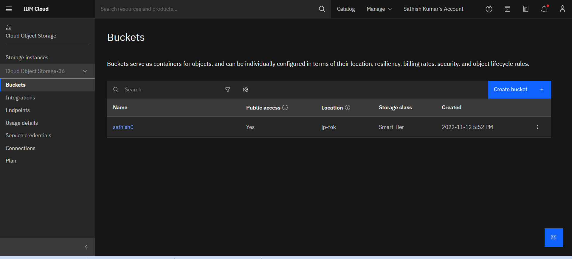

Uploading image in IBM bucket

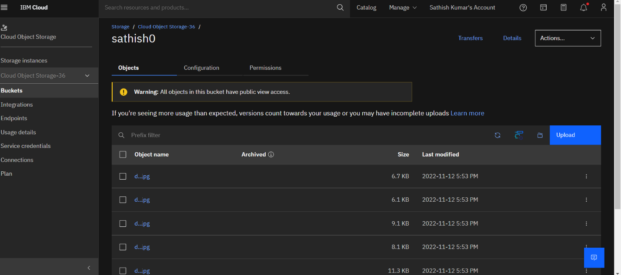

Source code of uploading image in html,csscode and wmbeded the chat bot

<!DOCTYPE html>

<html lang="en">

<head>

    <meta charset="UTF-8">

    <meta http-equiv="X-UA-Compatible" content="IE=edge">

    <meta name="viewport" content="width=device-width, initial-scale=1.0">

    <title>index - page</title>

    <style>

        h1{color:black;font-size: medium;font-style: italic;border-color: #349989;border-style:groove; }

        p{color:blue}

        body{background-color: rgb(166, 83, 243);

            display:flex;

            align-items:center;

            justify-content: center;

            flex-direction: column;

        }

        img{ height: 300px;border-radius: 20px;margin:50px 0px;padding:0px;}

    </style>

</head>

<body>

    <h1> welcome to Stylish trends </h1>

    <p> this grate time for you to make shoping in our website. the following images are example for our fashion world. so pleaese, hurry up make shoping in our website. thank you for your support to choosing in our website. we wish you welcome agagin and again.</p>

    <div>

        <img src="https://sathish0.s3.jp-tok.cloud-object-storage.appdomain.cloud/d%201.jpg "alt='fashion1'>

        <img src="https://sathish0.s3.jp-tok.cloud-object-storage.appdomain.cloud/d%202.jpg "alt='fashion2'>

        <img src="https://sathish0.s3.jp-tok.cloud-object-storage.appdomain.cloud/d%203.jpg "alt='fashion3'>

        <img src="https://sathish0.s3.jp-tok.cloud-object-storage.appdomain.cloud/d%204.jpg "alt='fashion4 '>

        <img src="https://sathish0.s3.jp-tok.cloud-object-storage.appdomain.cloud/d%205.jpg "alt='fashion5'>

        <img src="https://sathish0.s3.jp-tok.cloud-object-storage.appdomain.cloud/d%206.jpg "alt='fashion6'>

        <script>

            window.watsonAssistantChatOptions = {

              integrationID: "1a1ee3af-aff0-474a-8627-b774d6f5b46e", // The ID of this integration.

              region: "au-syd", // The region your integration is hosted in.

              serviceInstanceID: "5c78f2a2-450c-4a3d-8aad-ce62c0e3bb35", // The ID of your service instance.

              onLoad: function(instance) { instance.render(); }

            };

            setTimeout(function(){

              const t=document.createElement('script');

              t.src="https://web-chat.global.assistant.watson.appdomain.cloud/versions/" + (window.watsonAssistantChatOptions.clientVersion || 'latest') + "/WatsonAssistantChatEntry.js";

              document.head.appendChild(t);

            });

          </script>

    </div>

</body>

</html>

Output:

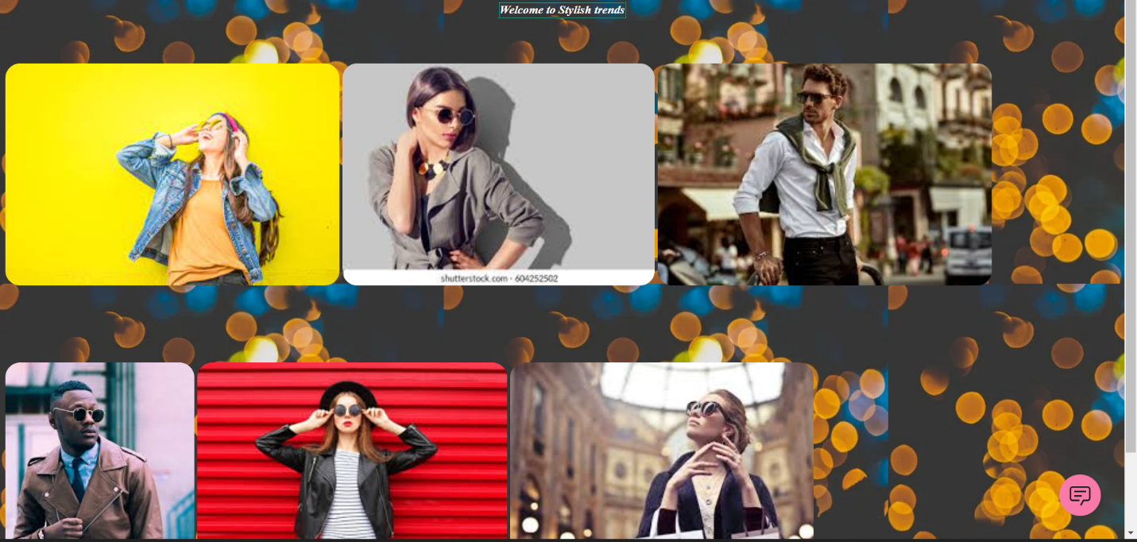

With chat box:

